

Programmed Name: **BCS**

Course Code: **(CSC 1610)**

Course Name: **DATA COMMUNICATIONS AND NETWORKING**

Assignment: **First**

Date**: 5/6/2020**

**Submitted By: Submitted To:**

Student Name: **Dipesh Tha Shrestha** Name: **SATYAM PAUDEL**

Section: **A**

Semester: **second**

Intake:**2019 September**

1. **A) Define the term converged network with the help of a diagram.**

Answer= Network convergence is the efficient coexistence of telephone, video and data communication within a single network. The use of multiple communication modes on a single network offers convenience and flexibility that are not possible with separate infrastructures.

**B) Define :**

**1) Brouter**

A bridge router or brouter is a network device that works as a bridge and as a router. The brouter routes packets for known protocols and simply forwards all other packets as a bridge would. Brouters operate at both the network layer for routable protocols and at the data link layer for non-routable

**2) Connection- oriented network**

Connection-oriented communication is a network communication mode in telecommunications and computer networking, where a communication session or a semi-permanent connection is established before any useful data can be transferred, and where a stream of data is delivered in the same order as it was sent.

**C) Compare and contrast Packet Switching and Circuit switching in a network.**

| **BASIS FOR COMPARISON** | **CIRCUIT SWITCHING** | **PACKET SWITCHING** |
| --- | --- | --- |
| Orientation | Connection oriented. | Connectionless. |
| Purpose | Initially designed for Voice communication. | Initially designed for Data Transmission. |

**D) Compare and contrast Bandwidth and throughput**

|  |  |
| --- | --- |
| **Bandwidth** | **Throughput** |
| Data capacity is travelled via a channel. | Practical measure of the amount of data actually transmitted through a channel. |

**E) List out the four difference between IP address and MAC address.**

|  |  |
| --- | --- |
| **MAC Address** | **IP Address** |
| * MAC Address stands for Media Access Control Address. | * IP Address stands for Internet Protocol Address. |
| * MAC Address is a six byte hexadecimal address. | * IP Address is either four byte (IPv4) or six byte (IPv6) address. |
| * A device attached with MAC Address can retrieve by ARP protocol. | * A device attached with IP Address can retrieve by RARP protocol. |
| * sMAC Address is used to ensure the physical address of computer. | * IP Address is the logical address of the computer. |

1. **The following question will test your knowledge on router coding. Marks is given based on complete executable commands**.
2. **Name of the router is to be changed to Seminarhall_Sunway**

**Answer:**

Router>enable

Router#config terminal

Enter configuration commands, one per line.End with CNTL/Z.

Router(config) #hostname Seminarhall_Sunway

Seminarhall_Sunway(config)#

1. **Set console password as Admin1234**

**Answer:**

Router>enable

Router#config terminal

Enter configuration commands, one per line. End with CNTL/Z

Router(config) #Line console 0

Router(config-line) #password Admin1234

Router(config-line) #login

Router(config-line) #

**c) Set a banner message "Network is being monitored and please stop your**

**illegal activity now.”**

**Answer:**

Router>enable

Router#config terminal

Enter configuration commands, one per line. End with CNTL/Z.

Router(Config) #banner motd #Network is being monitered and please stop your illegal activity now#

**d ) Assign IP address to Interface Fast Ethernet 0/0. The IP address is**

**192.168.50.1 and subnet mask is: 255.255.255.248.**

**Answer:**

Router>enable

Router#config terminal

Enter configuration commands, one per line.End with CNTL/Z.

Router(config) #interface gigabitEthernet 0/0/0

Router(config-if) #ip address 192.168.50.1 255.255.255.0

Router(config-if) #no shutdown

Router(config-if) #%LINK-5-CHNAGED: Interface GigabitEthernet0/0/0, Changed state to up

%LINEPROTO-5_UPDOWN: Line protocol on Interface GigabitEthernet0/0/0, Changed state to up

**e) Set the VTY password as cisco.**

**Answer:**

Router>enable

Router#config terminal

Enter configuration commands, one per line.End with CNTL/Z.

Router(config) #Line VTY 0 4

Router(config-line) #password cisco

Router(config-line) #login

1. **A) Describe each layer in OSI model in brief.**

**Answer**: The Each Layer of OSI model are given below:

i. Physical Layer:The lowest layer of the OSI Model is concerned with electrically or optically transmitting raw unstructured data bits across the network from the physical layer of the sending device to the physical layer of the receiving device. It can include specifications such as voltages, pin layout, cabling, and radio frequencies.

ii. Data Link Layer: At the data link layer, directly connected nodes are used to perform node-to-node data transfer where data is packaged into frames. The data link layer encompasses two sub-layers of its own. The first, media access control (MAC), provides flow control and multiplexing for device transmissions over a network. The second, the logical link control (LLC), provides flow and error control over the physical medium as well as identifies line protocols.

iii. Network Layer: The network layer is responsible for receiving frames from the data link layer, and delivering them to their intended destinations among based on the addresses contained inside the frame. The network layer finds the destination by using logical addresses, such as IP (internet protocol). At this layer, routers are a crucial component used to quite literally route information where it needs to go between networks.

iv. Transport Layer: The transport layer manages the delivery and error checking of data packets. It regulates the size, sequencing, and ultimately the transfer of data between systems and hosts. One of the most common examples of the transport layer is TCP or the Transmission Control Protocol.

v. Session Layer: The session layer controls the conversations between different computers. A session or connection between machines is set up, managed, and termined at layer 5. Session layer services also include authentication and reconnections.

vi. Presentation Layer: The presentation layer formats or translates data for the application layer based on the syntax or semantics that the application accepts. Because of this, it at times also called the syntax layer. This layer can also handle the encryption and decryption required by the application layer.

vii. Application Layer: At this layer, both the end user and the application layer interact directly with the software application. This layer sees network services provided to end-user applications such as a web browser or Office 365. The application layer identifies communication partners, resource availability, and synchronizes communication.

**B) Describe the functionality of all the protocols listed below in TCP/IP**

**Protocolsuite**. 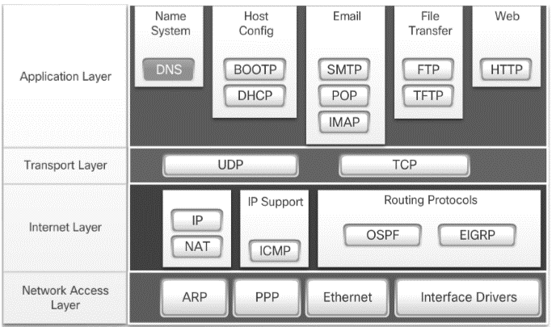

1.Application layer:

a.DNS: It is used for host names to the IP address resolution.

b.BOOTP: It is used to automatically assign an IP address to network devices from a configuration server.

c.DHCP: It dynamically assigns an IP address and other network configuration parameters to each device on a network so they can communicate with other IP networks.

d.SMTP: It is an internet standard for email transmission across IP networks that are typically only used for sending messages to a mail server for relaying.

e.POP: It helps to provide the end users the ability to fetch and receive email.

f.IMAP: It stores email messages on a mail server, but allows the end user to view and manipulate the messages as though they were stored locally on the end user's computing device.

g.FTP: It is used for file transfers from one host to another.

h.TFTP: It allows a client to get a file from or put a file onto a remote host.

i.HTTP: It is used to transfer files (text, graphic images, sound, video, and other multimedia files) on the World Wide Web.

2.Transport layer:

a. UDP: It is a connectionless protocol for data transfer. Since a session is not created before the data transfer, there is no guarantee of data delivery.

b.TCP: It is a connection-oriented protocol that enables reliable data transfer between two computers.

3.Internet Layer:

a.IP: It is used to deliver packets from the source host to the destination host based on the IP addresses.

b.NAT: It translates the IP addresses of computers in a local network to a single IP address.

c.ICMP: It is used to detects and reports network error conditions. Used in ping.

d.OSPF: It is used to distribute IP routing information throughout a single Autonomous System (AS) in an IP network.

e.EIGRP: It is used on a computer network for automating routing decisions and configuration.

4.Network Access Layer:

a.ARP: It is used to associate an IP address with a MAC address.

b.PPP: It is used to transmit multiprotocol data between two directly connected (point-to-point) computers.

c.Ethernet: It is used to transmit data from the network to your computer.

d.Interface Drivers: It allows transport protocols such as TCP/IP, IPX, and NetBEUI to communicate with an underlying network adapter.